Homework (Project) IV Multi-Agent Movement

# Due Dates: 10/16/17, 10pm (Submission on blackboard)

# Points: 15

# Assignment Type: you can work in groups of 1-3 people

# Introduction

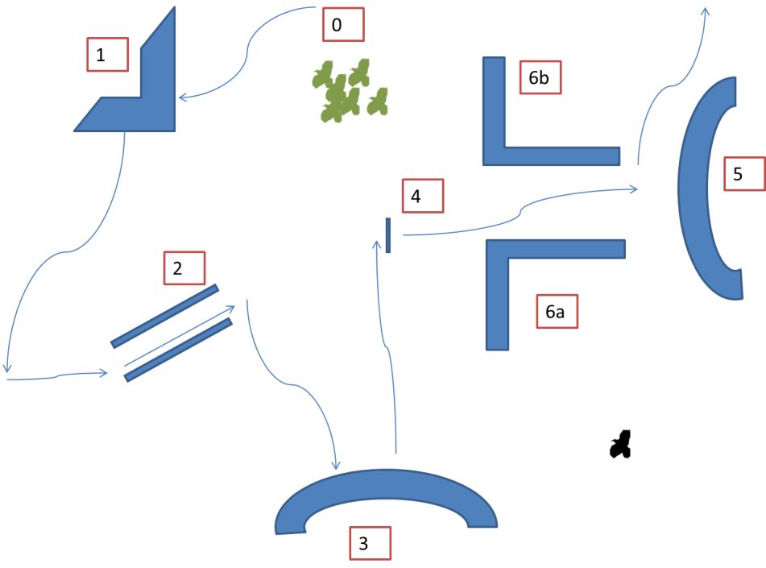

In this assignment, we will practice the basic formation algorithms.

* The first thing you need to do is to recreate the map as shown in the above picture
  + The tunnel in location 2 only allows 1 bird to pass, and the one between 6a and 6b allows for 3. The distances between other objects can be as far or as close as you want
  + The width of object 4 equals to 1 bird
  + The tunnel in location 2 is not parallel to the edge of the map
  + Blocks 3 & 5 have curved shapes
  + The gap between 5 and 6 can maximally allow 3 birds to go through together
  + Except between 5 and 6, there should be enough space in between of the obstacles, so that the formation can reshape to its original form
* Then you will need to create a group of 12 green birds in a) a scalable formation in the shape of your choice; b) an emerged formation in the shape of your choice; c) a two level formation with an invisible leader in the shape of your choice.
* For all three groups:
  + The leader should perform a path following algorithm and follow the path laid out by the blue arrows in the map.
    - In a and c, the leader should consider and check the max speed of the team members, and slow down when needed
    - In a, the leader should check if there is enough space for the entire formation to move around the corner with object 1.
  + For object 2, the team members need to go through the tunnels one by one; for object 6, two or three in a row
    - You need to supply additional rules for all three formations to do so
  + You will create a black bird which is controlled by mouse and keyboard. Once a blue bird is hit by this black bird, the blue bird will die and disappear. The group’s formation should adjust accordingly.

# Requirements

* You need to display the names of the formations.
* As usual, a clear user interface, and a readme are required.
  + In readme, please answer the following questions for each of the formations:
    - What did you use for obstacle avoidance?
      * You can use ray cast, cone check or collision predication
        + For ray cast, you can use Unity’s function if you wish
      * You cannot just use the colliders in Unity
    - What are the heuristics for the agents to go through the tunnels
    - Did you use any additional heuristics?
    - What are the differences in the three groups’ performances?